1. Create a function module to import a range of customer numbers and export the customer data for the given range.

Customer Data can be found in table KNA1.

Time : 30 minutes

Create a package and keep all objects created for this task in that package.

Paste screenshots of all the objects created for this task.

Submitted by Pournami Sunil

Package -ZPS_PACKAGE

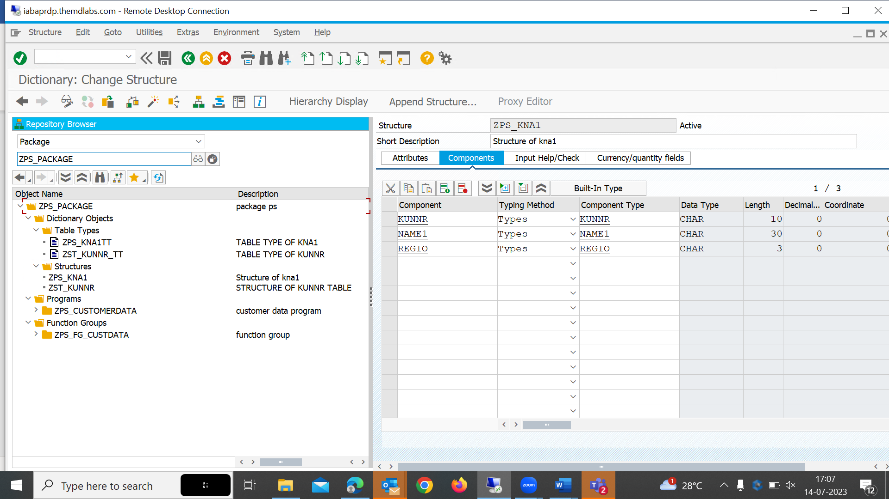

Function module : ZPS_FM_CUST_DATA

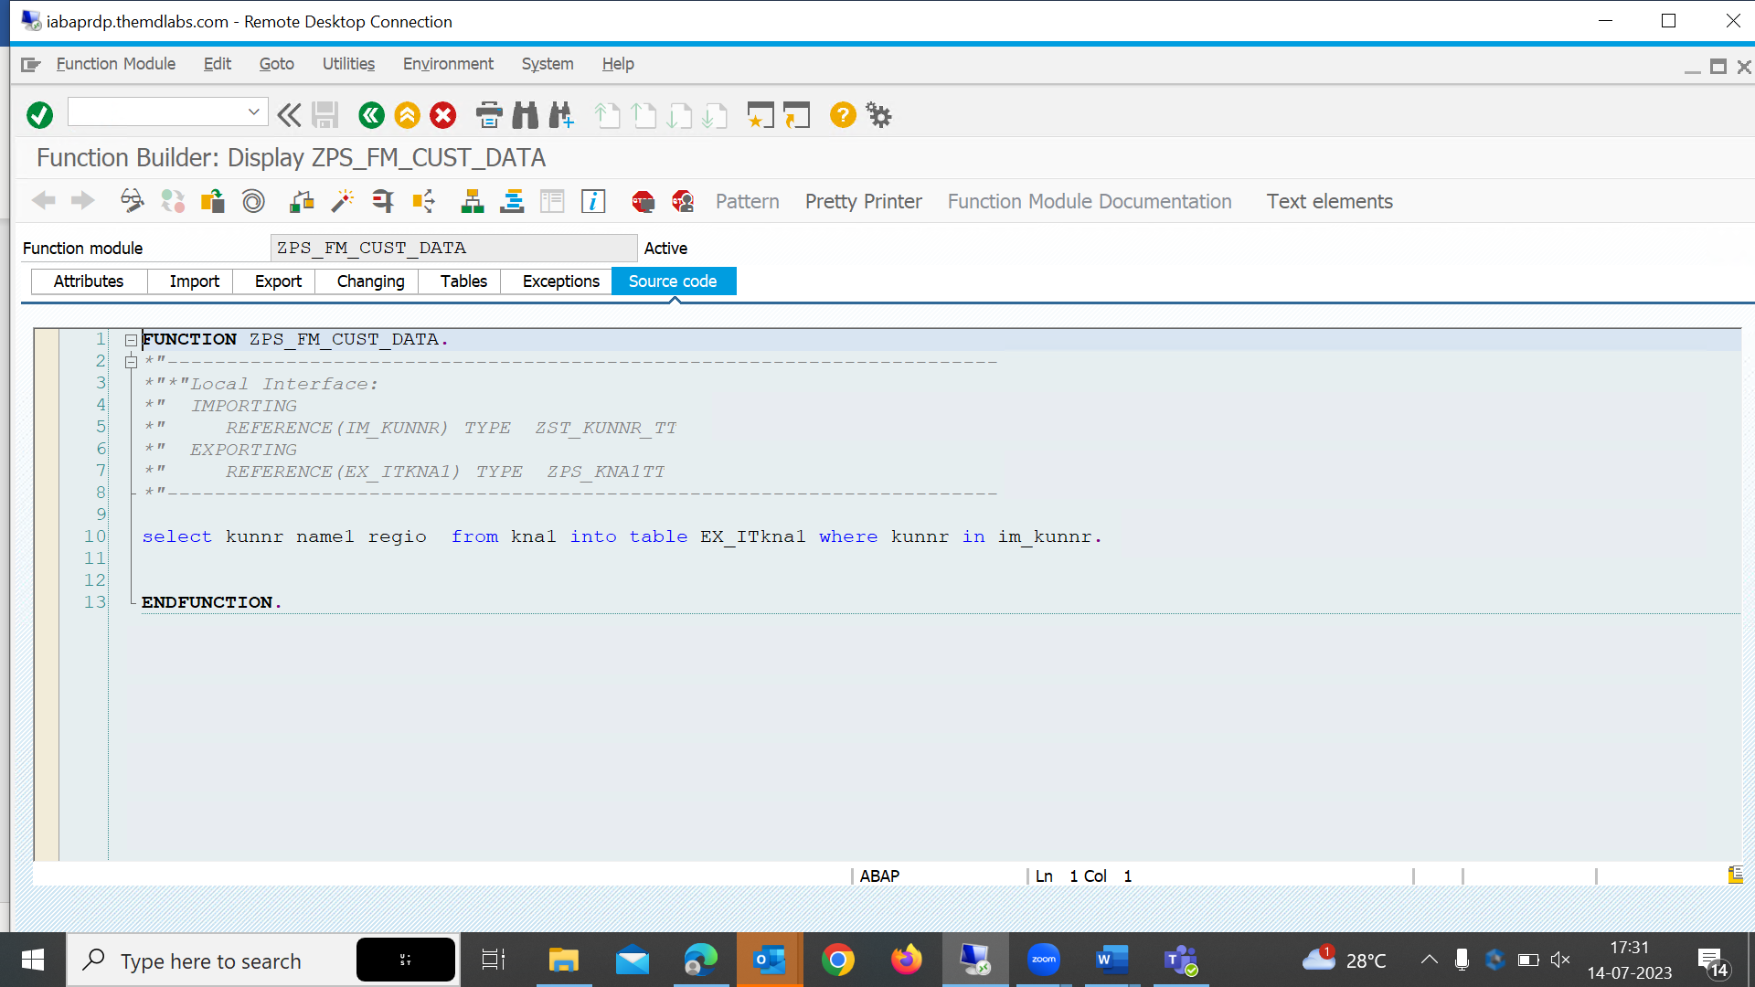

Program : ZPS_CUSTOMERDATA

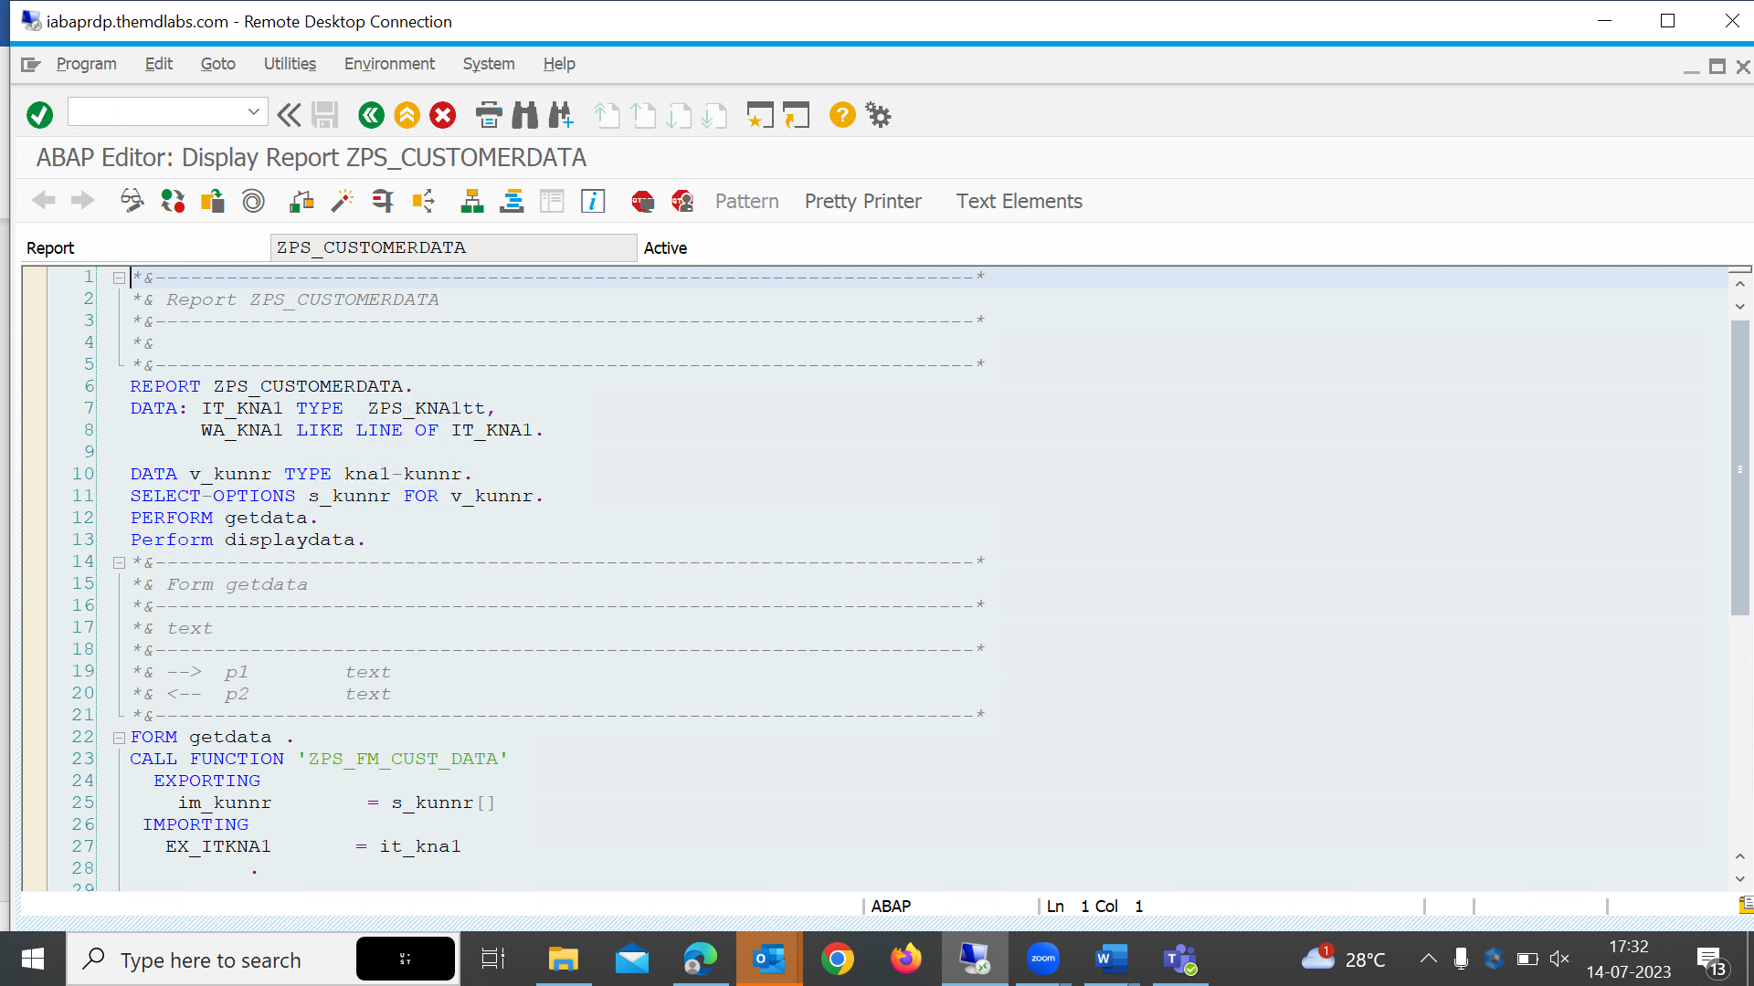

o/p

